Lab-10

Queries and screenshot:

**1**. List all the student details studying in fourth semester ‘C’ section.

**2**. Compute the total number of male and female students in each semester and in each section.

**3**. Create a view of Test1 marks of student USN ‘1BI15CS101’ in all subjects.

**4**. Categorize students based on the following criterion:

If FinalIA = 17 to 20 then CAT = ‘Outstanding’ If FinalIA = 12 to 16 then CAT = ‘Average’ If FinalIA< 12 then CAT = ‘Weak’ Give these details only for 8th semester A, B, and C section students.

**1.** SELECT * FROM STUDENT S,SEMSEC M,CLASS C

WHERE

S.USN=C.USN AND

C.SSID=M.SSID AND

M.SEM=4 AND

M.SEC="C"

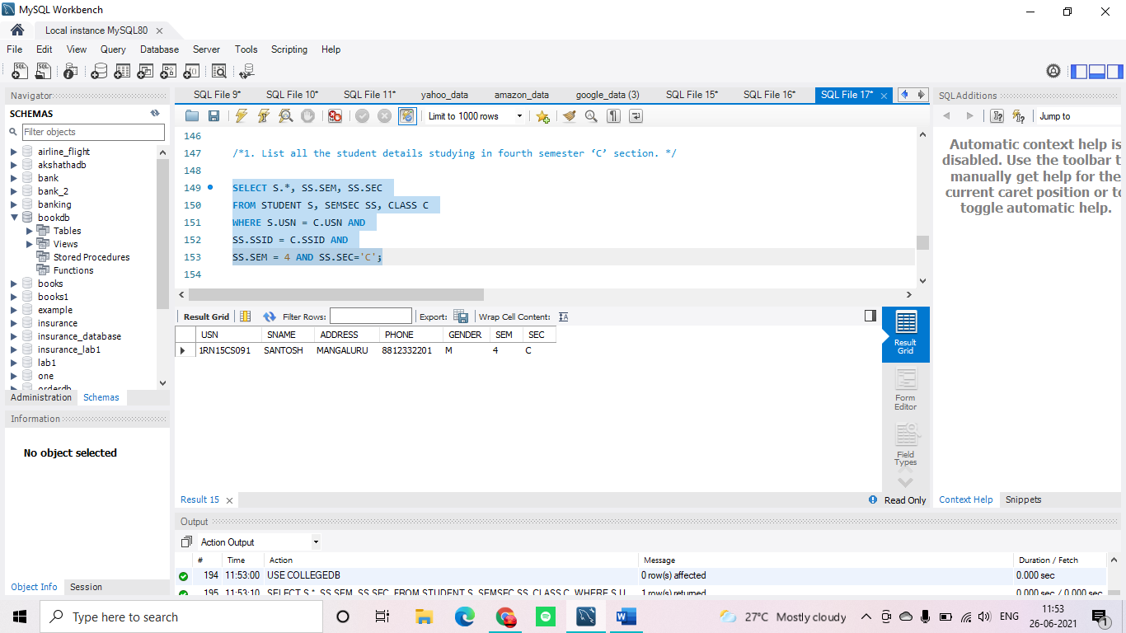

;

**2.** SELECT M.SEC,M.SEM,S.GENDER,COUNT(*) FROM STUDENT S,SEMSEC M,CLASS C

WHERE

S.USN=C.USN AND

C.SSID=M.SSID

group by

S.GENDER,M.SEM,M.SEC

ORDER BY M.SEM;

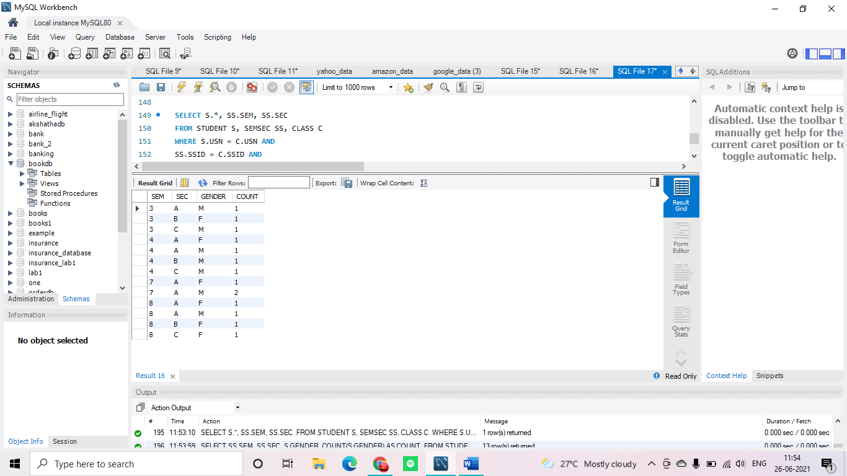

**3.** CREATE VIEW TEST1_1RN13CS091 AS SELECT SUBCODE, TEST1 FROM IAMARKS WHERE USN="1RN13CS091";

SELECT * FROM TEST1_1RN13CS091;

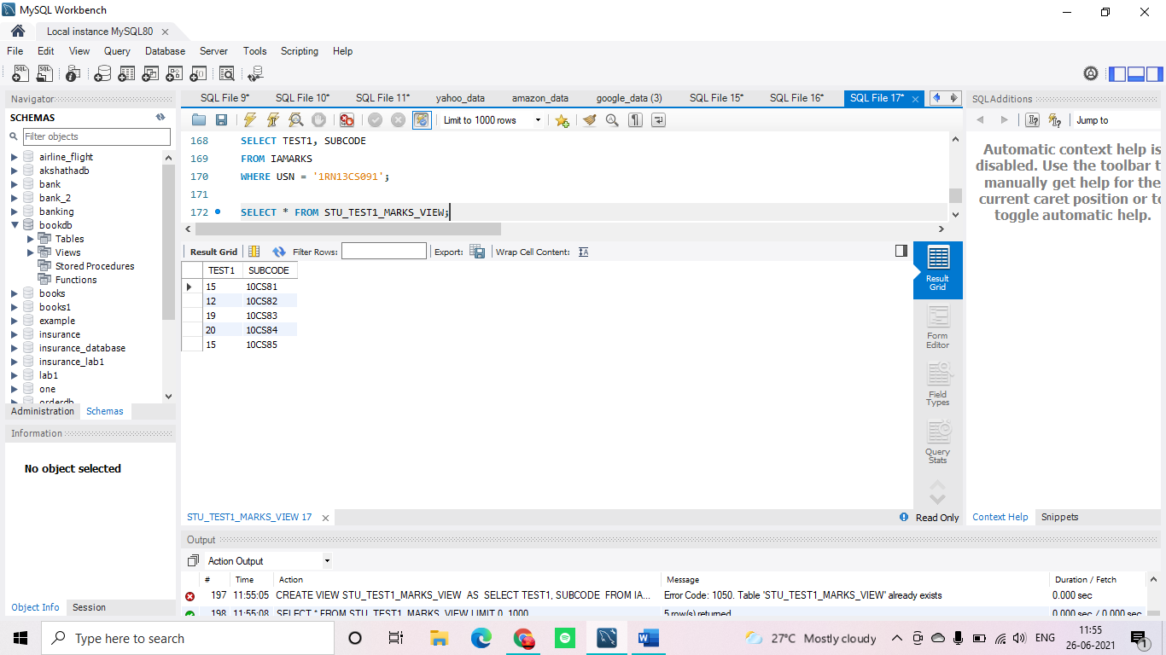

**4.** UPDATE IAMARKS SET FINALIA=(TEST1+TEST2+TEST3)/3;

select * from iamarks;

(SELECT I.USN,SUBCODE,FINALIA,"OUTSTANDING" FROM IAMARKS I,SEMSEC S WHERE S.SSID=I.SSID AND S.SEM=8 AND (S.SEC="A"OR S.SEC="B"OR S.SEC="C") AND FINALIA between 17 AND 20)

UNION

(SELECT I.USN,SUBCODE,FINALIA,"AVERAGE" FROM IAMARKS I,SEMSEC S WHERE S.SSID=I.SSID AND S.SEM=8 AND (S.SEC="A"OR S.SEC="B"OR S.SEC="C") AND FINALIA between 12 AND 17)

UNION

(SELECT I.USN,SUBCODE,FINALIA,"WEAK" FROM IAMARKS I,SEMSEC S WHERE S.SSID=I.SSID AND S.SEM=8 AND (S.SEC="A"OR S.SEC="B"OR S.SEC="C") AND FINALIA <12)

;

